**DATA SET-1**

Printed Tree for training dataset:

n= 600

node), split, n, loss, yval, (yprob)

* denotes terminal node

1) root 600 300 Yes (0.5000000 0.5000000)

2) XO< 0.5 277 113 Yes (0.5920578 0.4079422)

4) XM< 0.5 110 18 Yes (0.8363636 0.1636364) *

5) XM>=0.5 167 72 No (0.4311377 0.5688623)

10) XB>=0.5 53 21 Yes (0.6037736 0.3962264)

20) XI< 0.5 19 0 Yes (1.0000000 0.0000000) *

21) XI>=0.5 34 13 No (0.3823529 0.6176471)

42) XP>=0.5 17 6 Yes (0.6470588 0.3529412) *

43) XP< 0.5 17 2 No (0.1176471 0.8823529) *

11) XB< 0.5 114 40 No (0.3508772 0.6491228)

22) XD>=0.5 42 19 Yes (0.5476190 0.4523810)

44) XC>=0.5 11 0 Yes (1.0000000 0.0000000) *

45) XC< 0.5 31 12 No (0.3870968 0.6129032)

90) XF< 0.5 11 3 Yes (0.7272727 0.2727273) *

91) XF>=0.5 20 4 No (0.2000000 0.8000000) *

23) XD< 0.5 72 17 No (0.2361111 0.7638889)

46) XG< 0.5 35 13 No (0.3714286 0.6285714)

92) XF< 0.5 7 0 Yes (1.0000000 0.0000000) *

93) XF>=0.5 28 6 No (0.2142857 0.7857143) *

47) XG>=0.5 37 4 No (0.1081081 0.8918919) *

3) XO>=0.5 323 136 No (0.4210526 0.5789474)

6) XI< 0.5 127 61 Yes (0.5196850 0.4803150)

12) XM>=0.5 58 20 Yes (0.6551724 0.3448276)

24) XQ>=0.5 23 0 Yes (1.0000000 0.0000000) *

25) XQ< 0.5 35 15 No (0.4285714 0.5714286)

50) XF>=0.5 7 0 Yes (1.0000000 0.0000000) *

51) XF< 0.5 28 8 No (0.2857143 0.7142857) *

13) XM< 0.5 69 28 No (0.4057971 0.5942029)

26) XQ< 0.5 24 9 Yes (0.6250000 0.3750000)

52) XF>=0.5 11 0 Yes (1.0000000 0.0000000) *

53) XF< 0.5 13 4 No (0.3076923 0.6923077) *

27) XQ>=0.5 45 13 No (0.2888889 0.7111111) *

7) XI>=0.5 196 70 No (0.3571429 0.6428571)

14) XT>=0.5 84 39 No (0.4642857 0.5357143)

28) XS>=0.5 34 13 Yes (0.6176471 0.3823529) *

29) XS< 0.5 50 18 No (0.3600000 0.6400000) *

15) XT< 0.5 112 31 No (0.2767857 0.7232143)

30) XH< 0.5 52 19 No (0.3653846 0.6346154)

60) XP< 0.5 19 6 Yes (0.6842105 0.3157895) *

61) XP>=0.5 33 6 No (0.1818182 0.8181818) *

31) XH>=0.5 60 12 No (0.2000000 0.8000000) *

Plots for actual and the pruned tree:

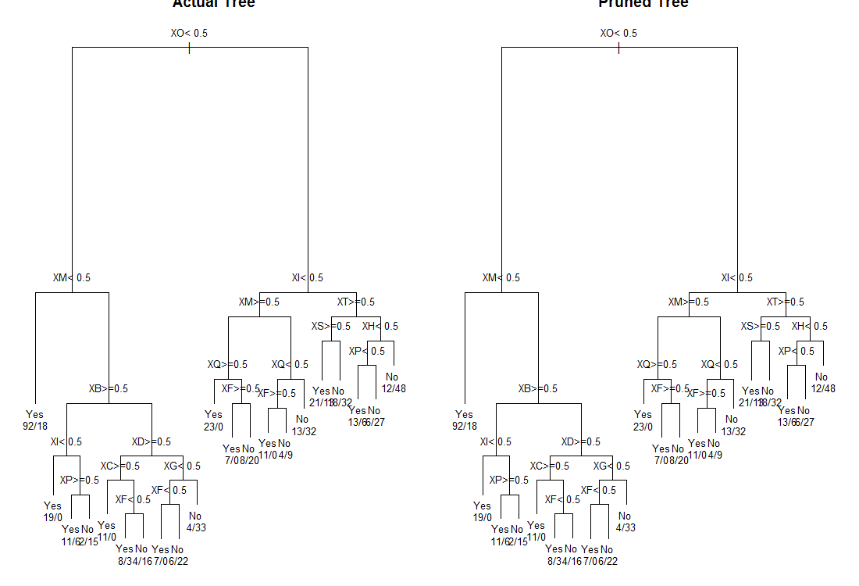

**DATA SET-2**

Printed Tree for dataset:

n= 600

node), split, n, loss, yval, (yprob)

* denotes terminal node

1) root 600 300 Yes (0.5000000 0.5000000)

2) XI< 0.5 301 121 Yes (0.5980066 0.4019934)

4) XU>=0.5 128 34 Yes (0.7343750 0.2656250)

8) XG>=0.5 46 0 Yes (1.0000000 0.0000000) *

9) XG< 0.5 82 34 Yes (0.5853659 0.4146341)

18) XS>=0.5 30 4 Yes (0.8666667 0.1333333) *

19) XS< 0.5 52 22 No (0.4230769 0.5769231)

38) XB>=0.5 21 8 Yes (0.6190476 0.3809524) *

39) XB< 0.5 31 9 No (0.2903226 0.7096774) *

5) XU< 0.5 173 86 No (0.4971098 0.5028902)

10) XQ< 0.5 65 24 Yes (0.6307692 0.3692308)

20) XF>=0.5 20 0 Yes (1.0000000 0.0000000) *

21) XF< 0.5 45 21 No (0.4666667 0.5333333)

42) XO< 0.5 17 4 Yes (0.7647059 0.2352941) *

43) XO>=0.5 28 8 No (0.2857143 0.7142857) *

11) XQ>=0.5 108 45 No (0.4166667 0.5833333)

22) XB>=0.5 35 12 Yes (0.6571429 0.3428571) *

23) XB< 0.5 73 22 No (0.3013699 0.6986301) *

3) XI>=0.5 299 120 No (0.4013378 0.5986622)

6) XK>=0.5 117 56 Yes (0.5213675 0.4786325)

12) XD>=0.5 27 0 Yes (1.0000000 0.0000000) *

13) XD< 0.5 90 34 No (0.3777778 0.6222222)

26) XT>=0.5 41 17 Yes (0.5853659 0.4146341)

52) XB>=0.5 15 0 Yes (1.0000000 0.0000000) *

53) XB< 0.5 26 9 No (0.3461538 0.6538462) *

27) XT< 0.5 49 10 No (0.2040816 0.7959184) *

7) XK< 0.5 182 59 No (0.3241758 0.6758242)

14) XC>=0.5 77 32 No (0.4155844 0.5844156)

28) XD>=0.5 20 5 Yes (0.7500000 0.2500000) *

29) XD< 0.5 57 17 No (0.2982456 0.7017544) *

15) XC< 0.5 105 27 No (0.2571429 0.7428571) *

Tree plots for actual and the pruned:

